# 

**YEAR 11 ATAR CHEMISTRY**

**UNITS 1 & 2**

**2018**

**MULTIPLE CHOICE QUESTION BOOKLET**

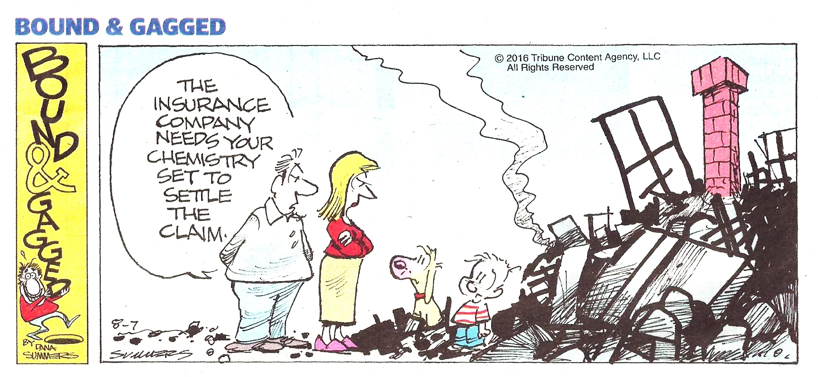

**Section One: Multiple-choice 25% (40 Marks)**

This section has **20** questions. Answer **all** questions on the separate Multiple-choice Answer Sheet provided. For each question **shade the box** to indicate your answer. Use only a blue or black pen to shade the boxes. If you make a mistake, place a cross through that square and shade your new answer, Do not erase or use correction fluid. Marks will not be deducted for incorrect answers.

**No marks will be given if more than one answer is completed for any question.**

Suggested working time: 35 minutes.

**Questions 1 and 2 relate to the information given in the following table.**

|  |  |  |  |  |
| --- | --- | --- | --- | --- |
|  | Atom | Number of protons | Number of neutrons | Electron configuration |
| **I** | sodium-22 | 11 | **W** | 2, 8, 1 |
| **II** | argon-40 | **X** | 20 | 2, 8, 8 |
| **III** | aluminium-27 | 13 | 14 | **Y** |
| **IV** | **Z** | 16 | 17 | 2, 8, 6 |

1. Which of the following correctly completes the table above?

**W X Y Z**

1. 11 18 2, 8, 3 sulfur-33
2. 12 20 2, 3 sulfur-33
3. 11 18 2, 8, 15, 2 oxygen-16
4. 12 8 2, 8, 3 sulfur-32

2. Which of these elements would have the highest electronegativity?

1. I
2. II
3. III
4. IV

3. Consider the structural drawing of an ethanol molecule shown below.



Which of the following statements regarding this molecule is **not** correct?

1. It has 7 polar bonds.
2. It has 1 non-polar bond.
3. It is a polar molecule.
4. It is a symmetrical molecule

4. Ethanol has a boiling point of 78.4 °C, while water has a boiling point of 100 °C under the same conditions. Therefore, if a sample of ethanol was compared to a sample of water at

25 °C, it must be true that

1. the vapour pressure of ethanol is greater than that of water.
2. the intermolecular forces in ethanol are stronger than those in water.
3. the density of ethanol is greater than that of water.
4. the boiling point of ethanol is higher than that of water.

5. A sample of 0.75 mol L-1 nitric acid solution was poured over a small amount of solid copper(II) oxide powder. Which of the following most accurately describes the observations that would be noted for the reaction that takes place?

1. A blue solid reduces in mass, a clear blue solution remains.
2. A blue solid reduces in mass, a colourless, odourless gas is produced.
3. A black solid reduces in mass, a clear blue solution remains.
4. A black solid reduces in mass, a colourless, odourless gas is produced.

6. Thin layer chromatography (TLC) was performed on five (5) different essential oils; bergamot, eucalyptus, lavandula, orange and pine. The TLC plate is shown below, along with the corresponding Rf value for each resolved component.

*bergamot eucalyptus lavandula orange pine*

Rf = 0.883

Rf = 0.5

Rf = 0.5

Rf = 0.233

Rf = 0.367

Rf = 0.267

Rf = 0.267

Rf = 0.667

Rf = 0.567

Rf = 0.417

Rf = 0.667

Rf = distance travelled by component

distance travelled by solvent

A small amount of an unknown essential oil, labelled as ‘Sample X’, was then analysed by TLC using identical running conditions. This plate is shown below. Use the data provided to determine which **two** essential oils have been mixed to produce ‘Sample X’.

solvent front = 5.5 cm

4.86 cm

3.12 cm

2.75 cm

1.28 cm

1. Bergamot and pine.
2. Eucalyptus and lavandula.
3. Orange and eucalyptus.
4. Lavandula and pine

7. The juice of blueberries can be used as an acid-base indicator. The diagram below shows the colour displayed by blueberry juice at various pH levels.

0 1 2 3 4 5 6 7 8 9 10 11 12 13 14

pH

|  |  |  |
| --- | --- | --- |
| red | purple | green |

Which pair of substances could be distinguished using the blueberry juice indicator?

1. HCl(aq) and H2O(l)
2. HCl(aq) and HNO3(aq)
3. NH3(aq) and Ba(OH)2(aq)
4. KOH(aq) and H2O(l)

8. Which statement regarding ions is **correct**?

1. Cations have a negative charge.
2. Negative ions have lost protons.
3. Positive ions have lost electrons.
4. An example of an anion is NH4+.

9. Use the following mass spectrometry data to calculate the relative atomic mass of zinc.

1. 65.34
2. 65.36
3. 65.38
4. 65.40

10. Consider the three (3) solvents shown below.

|  |  |  |
| --- | --- | --- |
| Methanoic acid | Dichloromethane | Hexane |
| HCOOH(l) | CH2Cl2(l) | C6H14(l) |
|  |  |  |

Ammonia (NH3) will be soluble in;

1. methanoic acid only.
2. dichloromethane only.
3. hexane only.
4. methanoic acid and dichloromethane only.

11. HPLC can be used for analysing the presence and type of amino acids in food and drink. The chromatographs for milk, soy sauce and beer are shown below, each indicating the five (5) most common amino acids present (labelled in capital letters). Each sample was run under identical conditions.

A sample of apple juice was analysed by gas chromatography, using the same conditions as above, and the chromatograph is shown below.

What is the amino acid composition of apple juice?

1. A, P, N, D, E
2. G, V, P, D, E
3. A, P, N, E, Y
4. G, P, N, D, W

12. Which of the following is **correct** for a 1.0 mol L-1 solution of ethanoic acid?

(a) c(H+) > c(CH3COOH)

(b) c(H+) < c(CH3COO-)

(c) c(CH3COOH) > c(CH3COO-)

(d) c(CH3COOH) = c(H+)

13. A sample of gas is stored in a sealed container at 20 °C. If this gas was an **ideal** gas, then according to the kinetic theory, which of the following statements is **not** correct?

1. If the container was cooled to absolute zero the gas volume would be zero.
2. If the container was heated to 100 °C the pressure would increase.
3. If the volume of the container was halved the gas particles would move faster.
4. If more gas was added to the container the pressure would increase.

14. When 5 mL of potassium carbonate solution (K2CO3) was mixed with 10 mL of ethanoic acid solution (CH3COOH) a chemical reaction took place. Which of the following gives the balanced ionic equation for this reaction?

1. CO32-(aq) + 2 CH3COOH(aq) → 2 CH3COO-(aq) + CO2(g) + H2O(l)
2. K2CO3(s) + 2 CH3COOH(aq) → 2 K+(aq) + 2 CH3COO-(aq) + CO2(g) + H2O(l)
3. CO32-(aq) + 2 H+(aq) → CO2(g) + H2O(l)
4. K2CO3(aq) + 2 H+(aq) → 2 K+(aq) + CO2(g) + H2O(l)

**Questions 15, 16, 17, and 18 relate to the five substances in the table below.**

|  |  |
| --- | --- |
|  | **Name of substance** |
| **I** | sulfurous acid |
| **II** | calcium phosphate |
| **III** | nickel bromide |
| **IV** | dinitrogen tetroxide |
| **V** | air |

15. Which of the following lists the correct formulas for each substance?

**I II III IV**

1. H2S CaPO4 NiBr N2O3
2. H2SO3 Ca3PO4 NiBr3 N2O4
3. H2SO4 Ca2(PO4)3 NiBr2 N2O4
4. H2SO3 Ca3(PO4)2 NiBr2 N2O4

16. Which of the following statements does **not** help to explain why substance V has no formula?

1. Air is not a pure substance.
2. Air has a variable molecular weight.
3. Air is composed of many different substances.
4. Air has a variable composition.

17. Which substance(s) would conduct electricity when mixed with water?

1. I only
2. II and III only
3. III only
4. I and III only

18. Which substance is likely to have the highest melting point?

1. I
2. II
3. IV
4. V

19. Which of the following statements **cannot** be explained by the presence of hydrogen bonding?

(a) Solid water is less dense than liquid water.

(b) Water is a highly polar molecule.

(c) Water has a high surface tension.

(d) Water has a high melting point for a molecule of its molecular weight.

20. Consider the energy profile diagrams shown below, for Reaction A and Reaction B.

**Reaction A Reaction B**

Which of the following wouldbe **correct** regarding reactions A and B?

1. Reaction B is likely to proceed at a faster rate.
2. Reactant particles in A likely contain stronger bonds than those in B.
3. Reactant particles in B need less energy than those in A, in order to react.
4. The temperature change measured for Reaction A and B would be the same.

**End of Section One**